Assignment 1: Algorithm And Flowchart

Name: Harshal Atre Balkrishna

Roll NO. : A-76

1.Write an algorithm and design a flowchart to swap two numbers with and without using a  temporary variable

Answer:

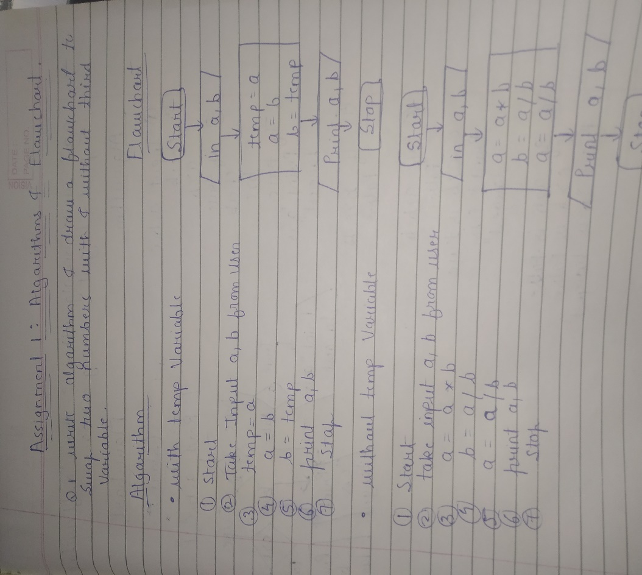

2. Write an algorithm and draw a flowchart to print the largest number among the entered three numbers.

Answer:

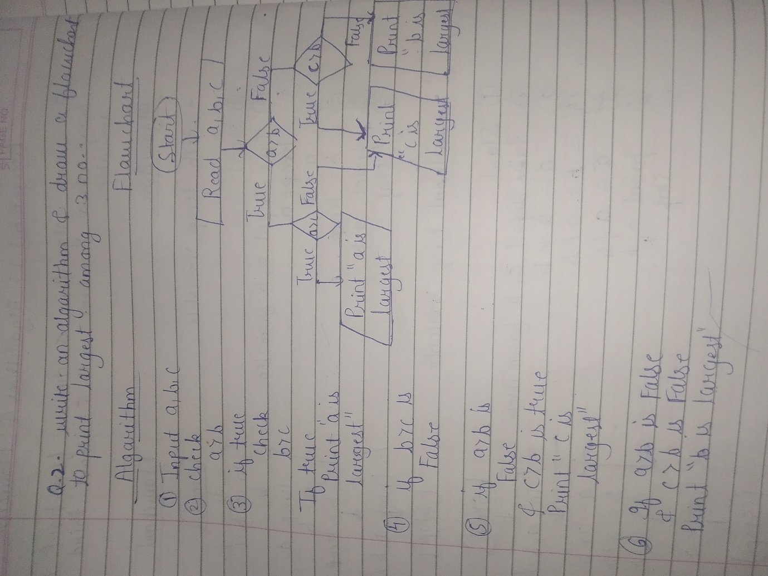

3. Write an algorithm and draw a flowchart to print the sum and average of first n natural  numbers.

Answer:

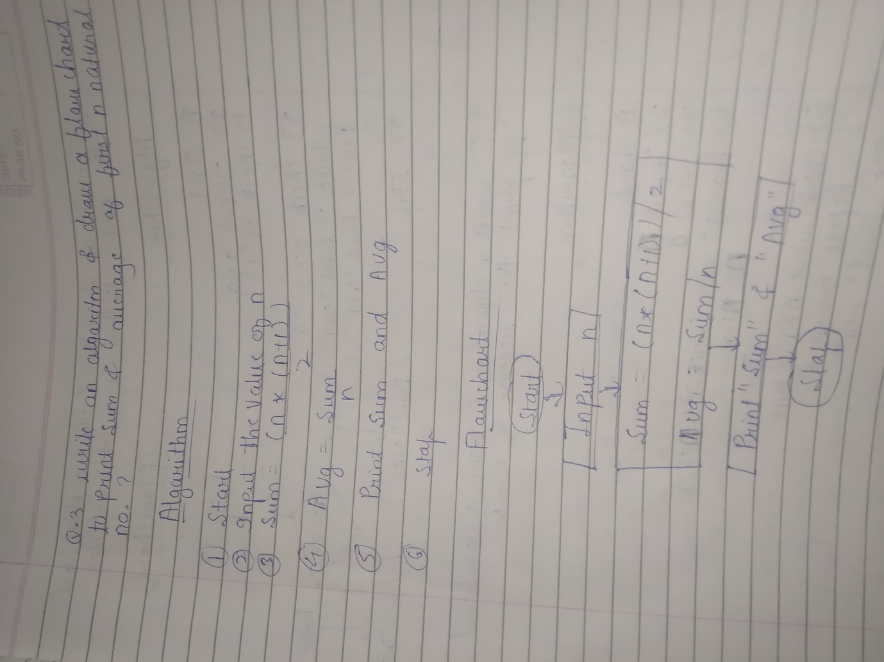

4. Write an algorithm and draw a flowchart to find whether a given number is odd or even

Answer:

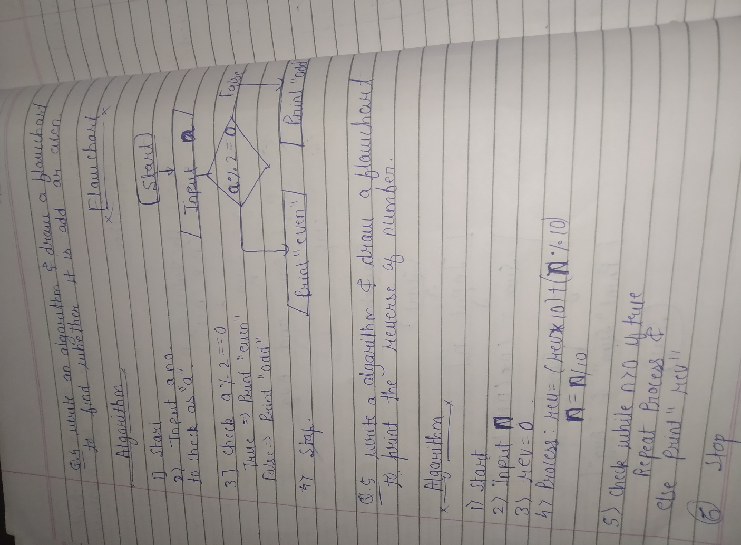

5. Write an algorithm and draw a flowchart to print the reverse of a given number.

Answer:

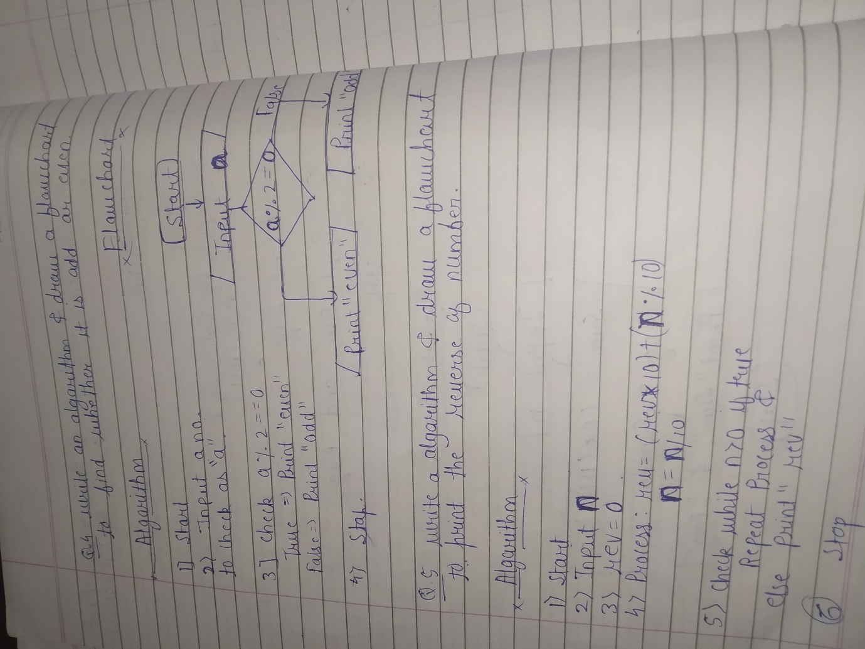

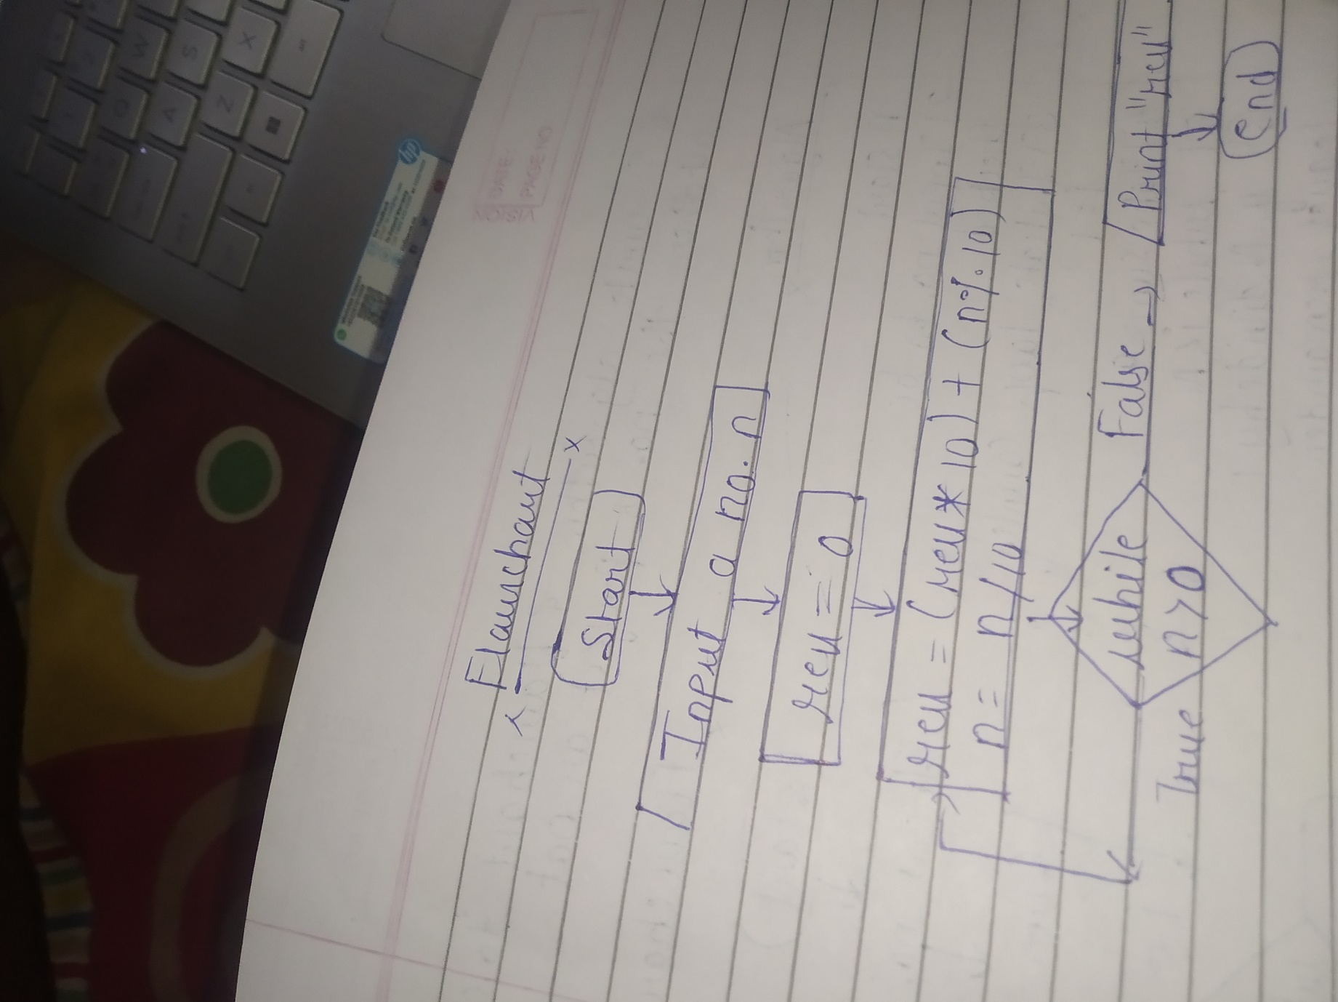

6. Write an algorithm and draw a flowchart to find whether the given number is the  Armstrong number or not. (Num =153 is Armstrong number as 13 + 53 + 33 = 153).

Answer:

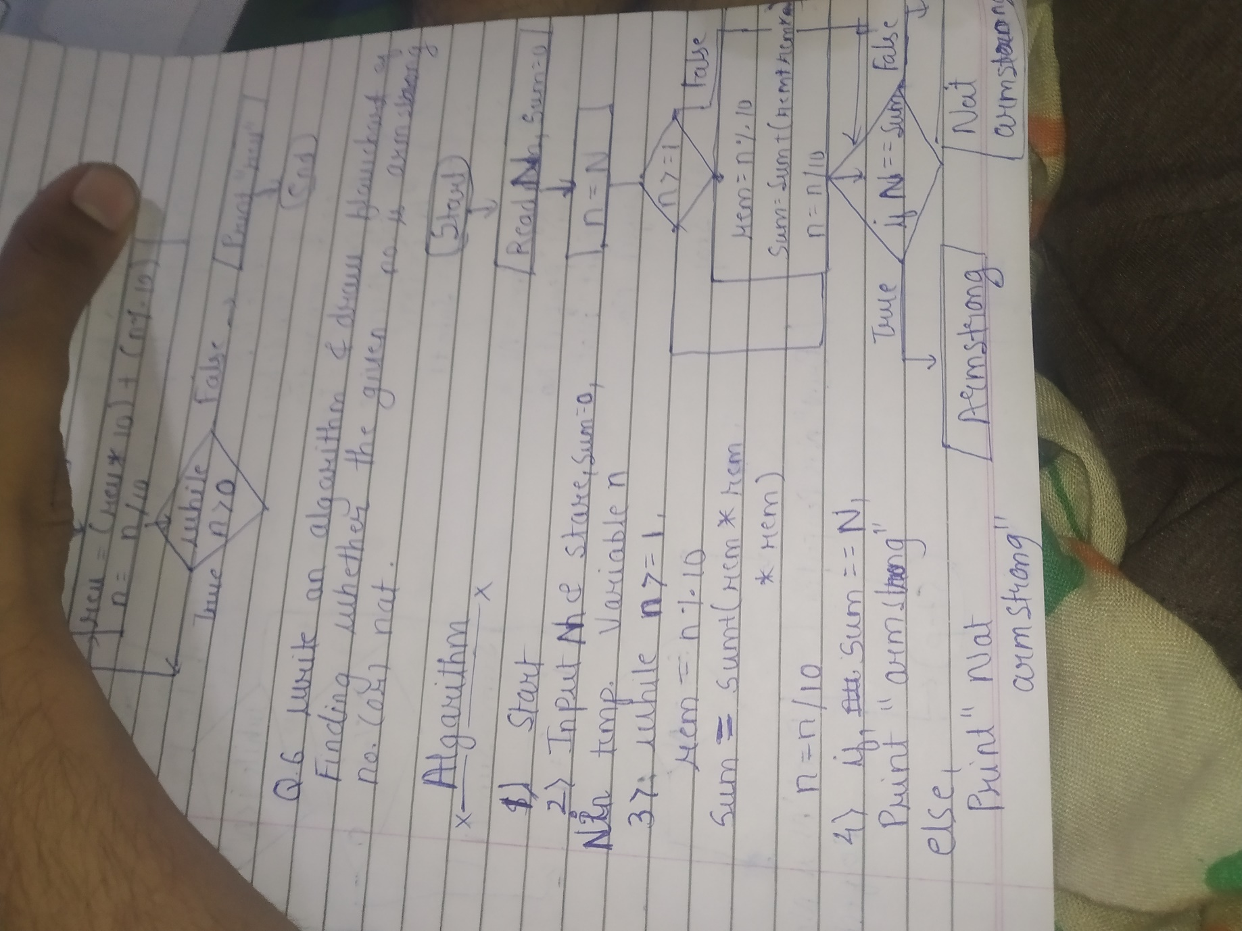

7. Write an algorithm and draw a flowchart to check whether the given number is perfect  number or not. The perfect number is one that equals to the sum of its divisors (excluding  number itself). 28 = 1+2+4+7+14; 6 = 1+2+3.

Answer:

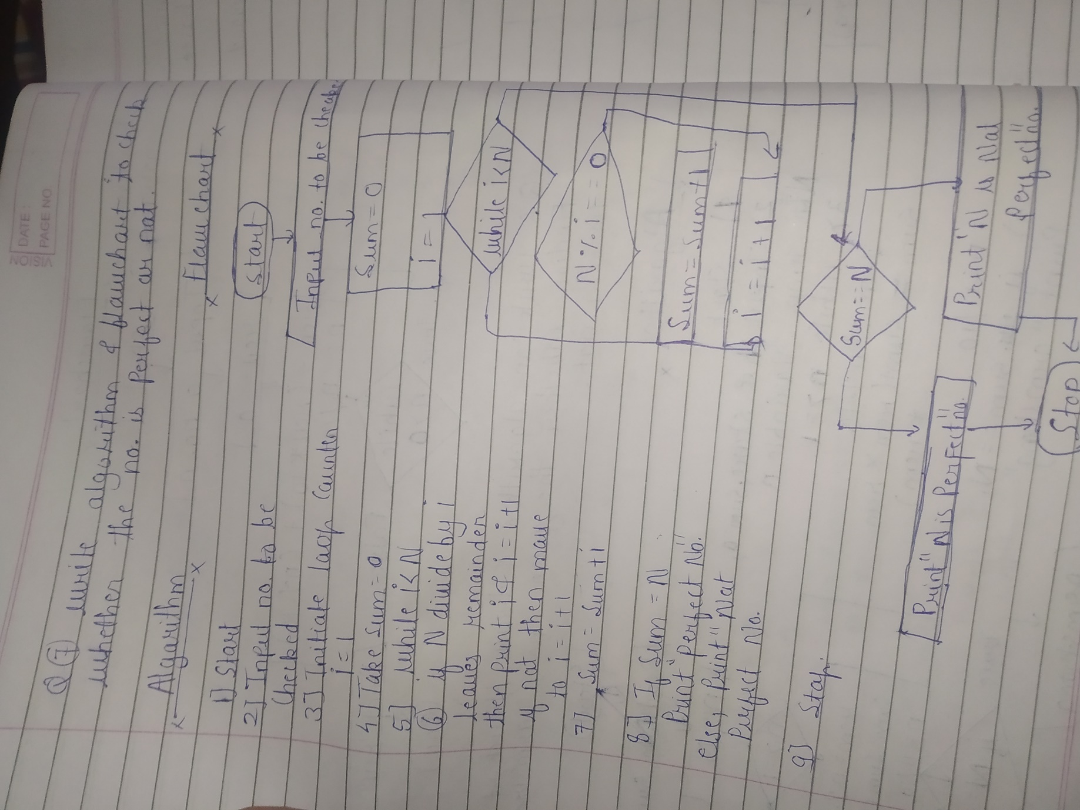

8. The current year and the year in which the employee joined the organization are entered  through the keyboard. If the number of years for which the employee has served the  organization is greater than 3, then a bonus of Rs. 2500/- is given to the employee. If the  years of service are not greater than 3, then the program should do nothing. Write an  algorithm and draw a flowchart for this problem.

Answer:

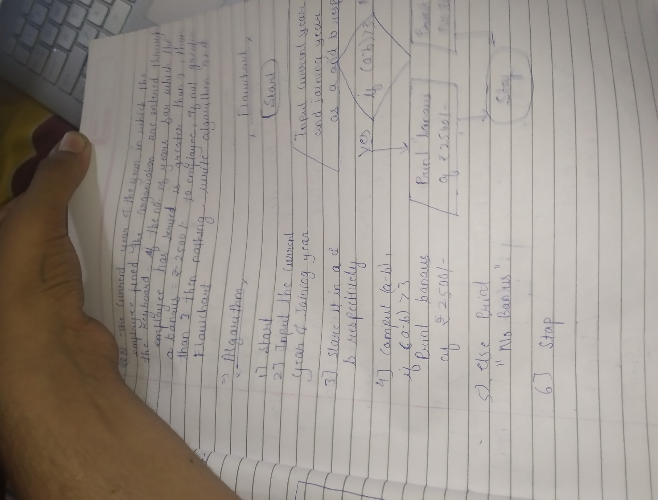

9. While purchasing certain items, a discount of 10% is offered if the quantity purchased is  more than 1000. If the quantity and price per item are input through the keyboard, write  an algorithm and draw a flowchart to calculate the total expenses.

Answer:

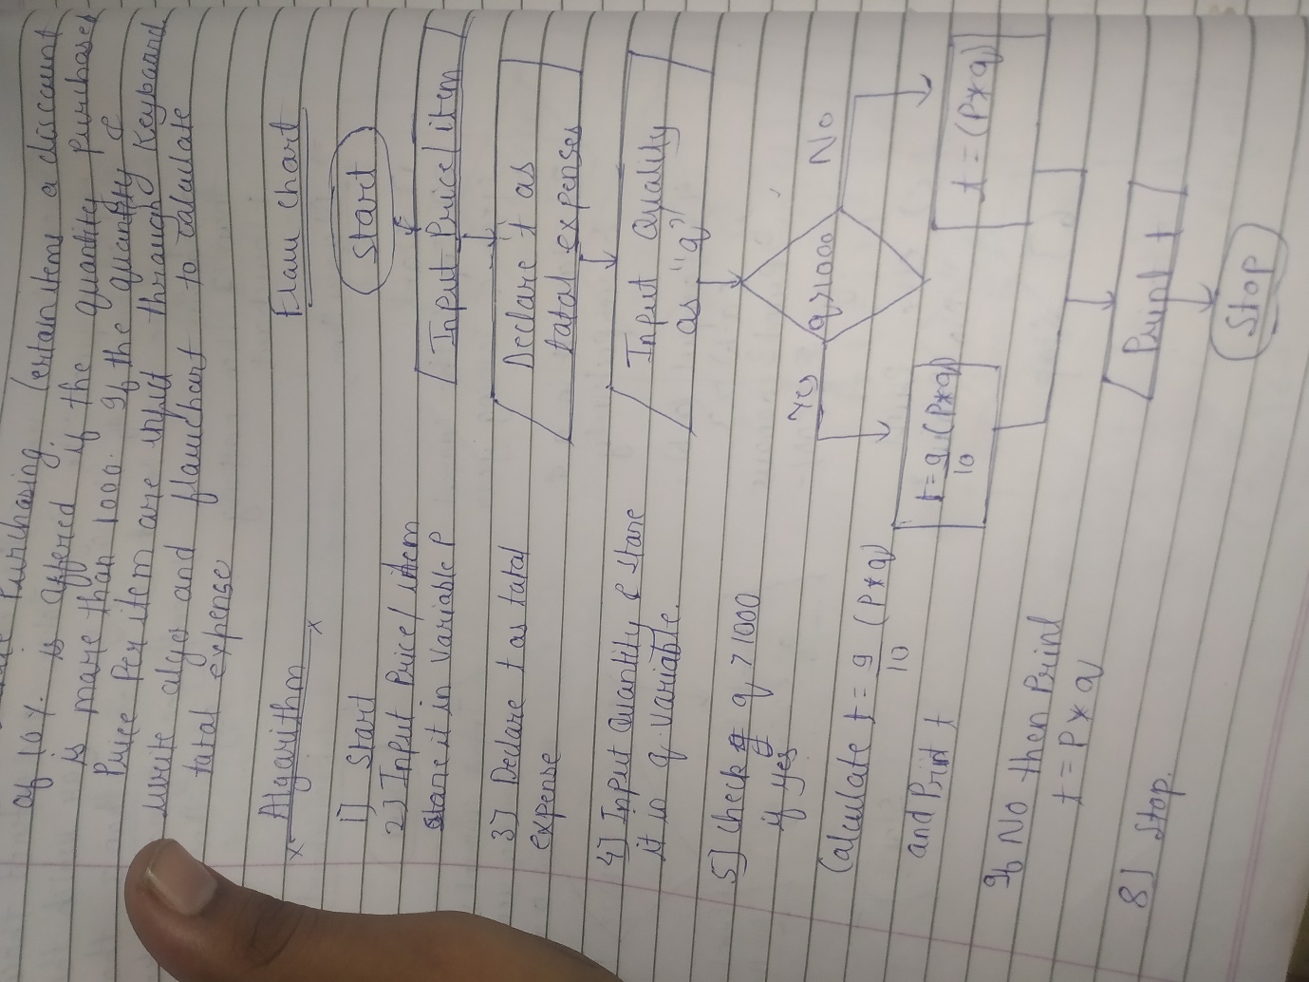

10. In a company an employee is paid as under: If his basic salary is less than Rs. 150000,  then HRA = 20% of basic salary and DA = 95% of basic salary. If his salary either equal  to or above Rs.150000, then HRA = Rs.25000 and DA = 87% of basic salary. If the  employee’s salary is input through the keyboard write an algorithm and draw a flow chart  to find his gross salary. Note : GrossSalary = BasicSalary + HRA + DA

Answer:

